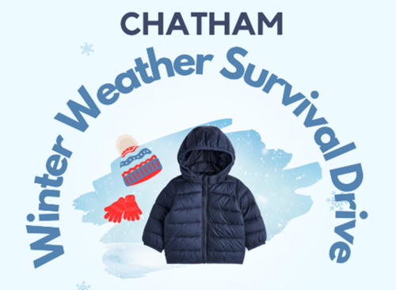

**Chatham Winter Weather Survival Drive Program 2024/2025**

**Executive Summary:**

**Introduction:**

The Chatham Winter Weather Survival Drive Program (WWSD) provides protection from the dangers of winter weather to the County’s most vulnerable population including the unsheltered, inadequately housed, those without heat and without the financial resources to afford winter outerwear, blankets and sleeping bags. In a community that currently does not have an emergency homeless shelter or a warming center we have too many individuals and families that literally attempt to survive in sub-freezing temperatures in sheds, barns, cars, abandoned trailers or nomadically sleeping on floors when possible. In lieu of improving County resources, the Chatham WWSD Program collects and distributes winter outerwear to those in need.

**Programs and Services:**

The Chatham WWSD secures donation drop-off/collection locations throughout the County at convenient, easily accessible locations at times and days with the goal of maximizing success to the donating public. Collected items are processed and stored pending distribution. Distribution events are organized and executed at multiple locations in the County. Additional resources such as food service and hygiene kits are distributed when available.

In 2023/24 there were eight collection locations in North Chatham, Pittsboro, Siler City and Goldston. Chatham WWSD 80 volunteers picked up, transported, processed and maintained inventory at 79 West Mosaic, a major sponsor. Distribution Events were organized and held in a dignified, welcoming environment like a retail shopping experience. A café for food service and hygiene kits were provided. In addition, inventory was continuously maintained and provided to Chatham County direct service providers for their clients including Salvation Army, Sheriff’s Department, CC School System, Love Chatham, Central Piedmont Community Action, Chatham Housing Authority. 4850 items were collected and distributed at three large events to over 700 people and to many more through direct service organizations.

**Financial Overview:**

As a volunteer start-up project, the launch of the Chatham WWSD 2023/24 was dependent on primary funders Melanie and Jeffrey York as well as several anonymous donors totaling $3,000. Sponsors made possible facility rental waiver for processing, storage, distribution events, transportation, equipment, and food service. Partnerships with many organizations across the County made the project possible. The continuation and sustainability of the WWSD Program 2024/25 will be dependent on maintaining and expanding sponsorship and funding.

**Impact and Success Stories:**

Over 700 people and many clients of direct service organizations received 4,850 new or gently used winter coats, hats, gloves, scarves, sweaters, sweatshirts, socks, blankets and sleeping bags. There are many uplifting examples. Here are two: the WWSD team learned from the Chatham County School System in January that there were many young children that were coming to school without winter outerwear. On three different occasions we acquired over 50 specific sized new coats and delivered them to grateful School Administration personnel. We visited and provided winter clothing for a young family of four with a newborn infant, three-year-old, mother and father without the means to be properly clothed. When we placed an adorable brightly colored handmade hat on the little boy’s head you could see the joy that this simple act of kindness brought to this family in need.

**Future Goals and Plans:**

The Chatham Winter Weather Survival Drive Program has the following goals:

Short-Term: Service Capacity Building

* Expand collection locations.
* Recruit and expand volunteer workforce.
* Expand transportation.
* Secure permanent processing /storage/distribution center(s).
* Focus collection efforts on providing all McKinney-Vento identified homeless children in CC School System with winter outerwear (in 2023/24-363 children).
* Expand Distributions to more locations with increased frequency.

Short-Term: Organizational Capacity Building

* Expand Partnerships with other organizations.
* Secure more sponsors that would provide outerwear in volume.
* Increase marketing/ publicity and communication broadly across the County.
* Develop and maintain a Chatham WWSD website.

Long-Term:

* Transition from seasonal WWSD to year-round operation.
* Secure a permanent facility for collection, storage, processing, and distribution.
* Expand scope and volume of inventory.
* Establish 501(c)3 status.
* Establish a Family Foundation for more sustainable funding source.

**Program Needs**

* Processing/Storage center in Siler City or Western Chatham area.
* Volunteer recruitment for Siler City Processing/Storage center.
* Interns and additional volunteer lead team members.
* Transport vehicle.
* Website and technical support.
* Marketing/signage.
* Additional equipment.
* Non-profit partner/affiliate or non-profit status.

**Call to Action:**

The Chatham WWSD Program asks for support to expand access to winter weather items with the goal of eliminating any Chatham County residents’ need for warm protections. To be a sustainable resource to our community we need a strong leadership team, volunteers, sponsors, partners, and funds to maintain the success we have realized in 2023/24 and to expand our operations to serve more families, and particularly a focused effort to children in need. We ask for your support!

**Contact: Melanie and Jeffrey York**

[**myork928@gmail.com**](mailto:myork928@gmail.com)

**919 880-3100**

**2023/24 Project Summary Report:** <https://tinyurl.com/ChathamWWSD>